**Screen Grabs of our working application**

First, user have to login.

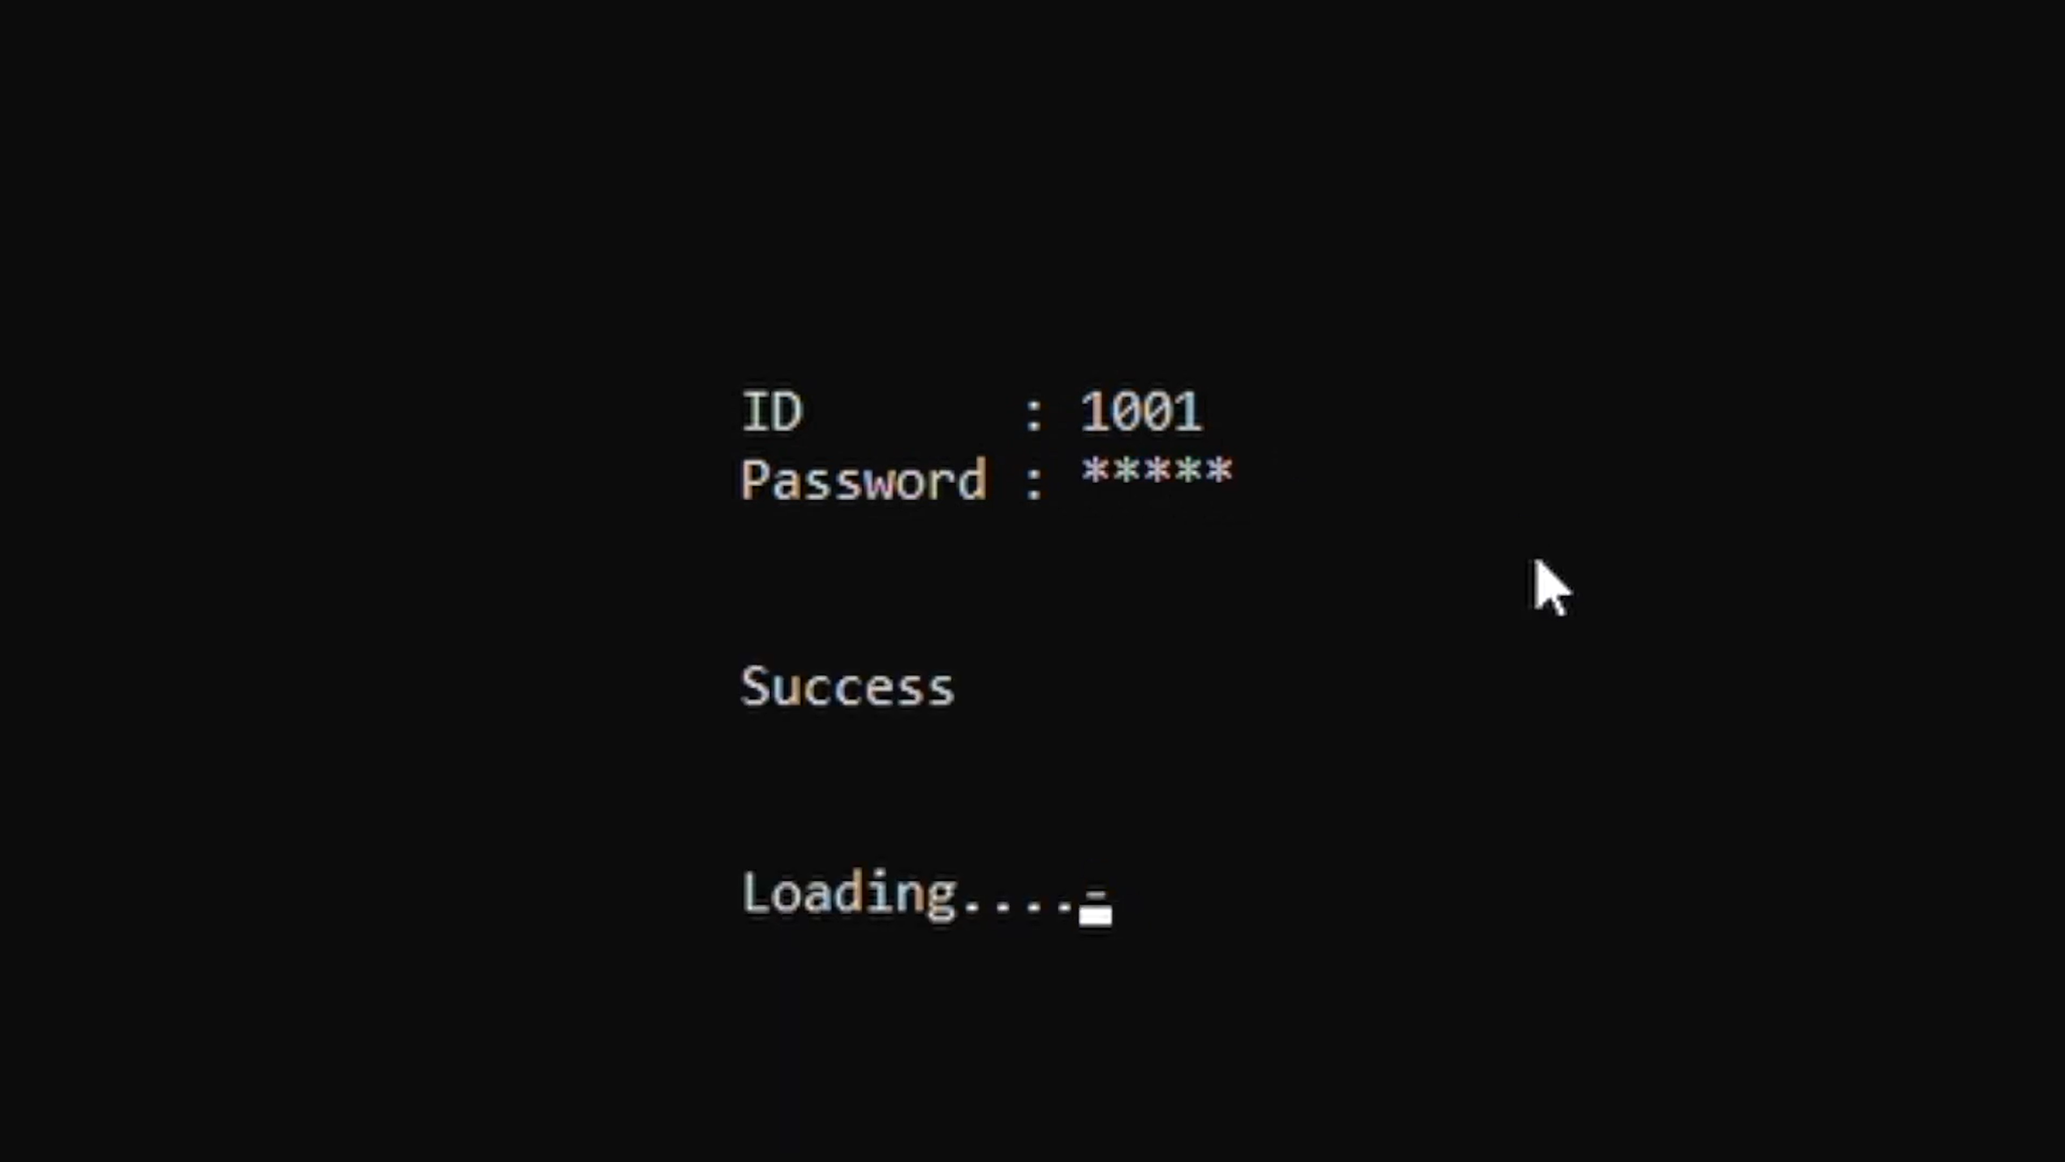

If the user is a **student**, he can see his information and do some action.

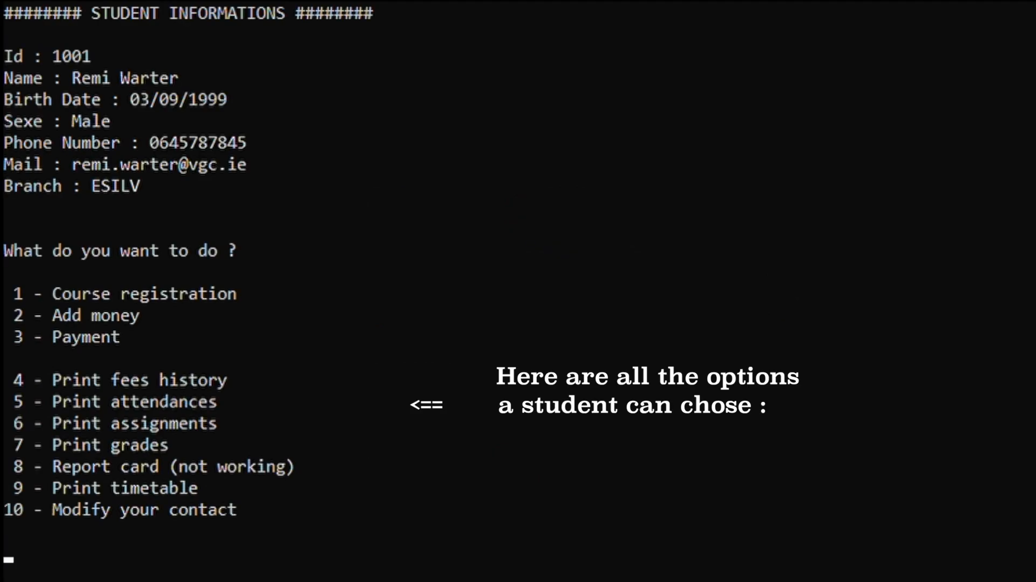

For example, he can pay his fees. There are two process, he can pay once or thrice if he wants.

He can also see his timetable.

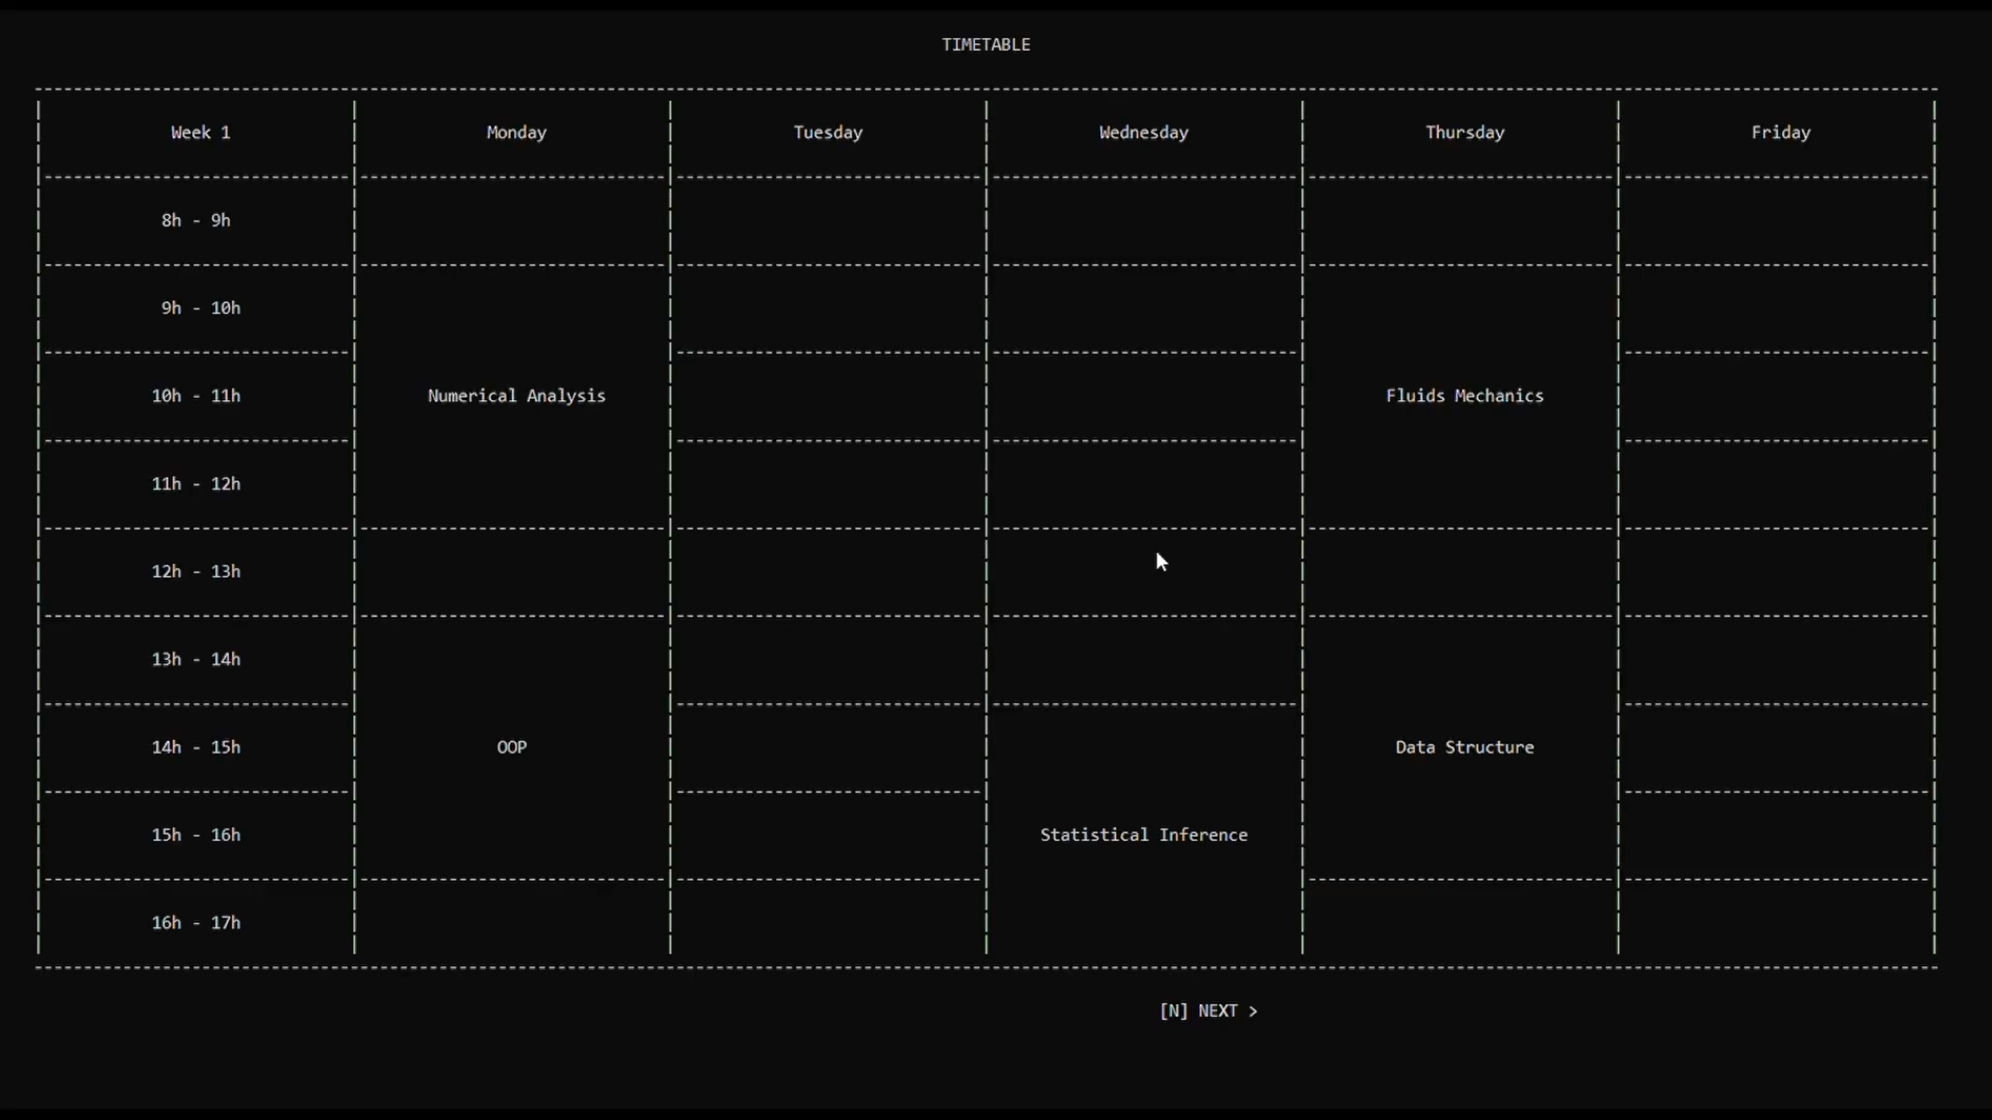

If the user is an **administrator**, he can see his information and do 13 actions.

For example, he can print student fees history.

If the user is a teacher, he can do 7 actions.

For example, he can add assignment in student’s timetable.

